CS 255 System Design Document Jonathan Brennan

UML Diagrams

UML Use Case Diagram
[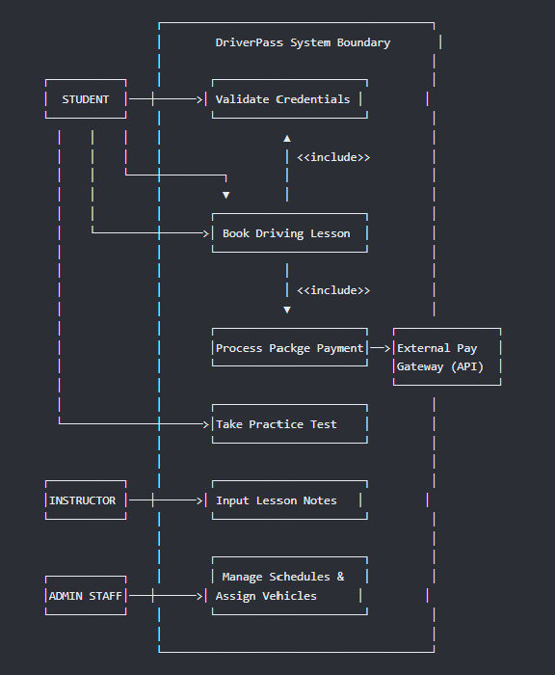]

UML Activity Diagrams

Activity Diagram: Taking an Online Practice Test

[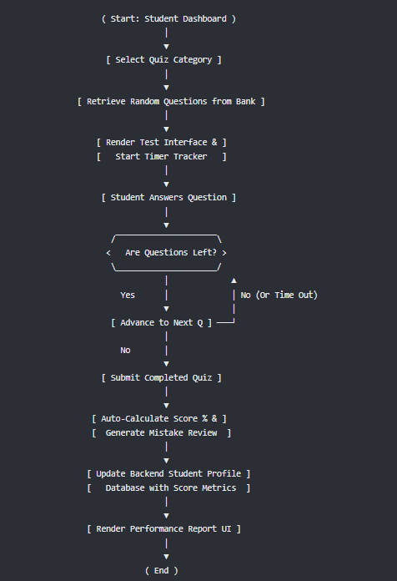]

Activity Diagram 2: Instructor Inputting Lesson Feedback
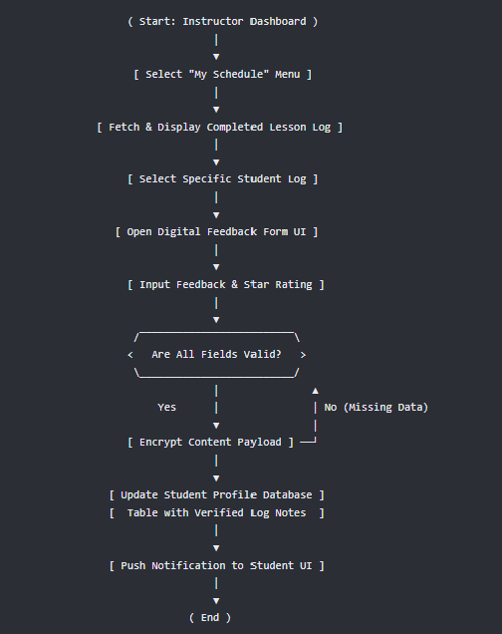

UML Sequence Diagram
[
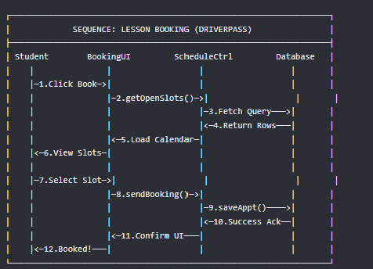]

UML Class Diagram
[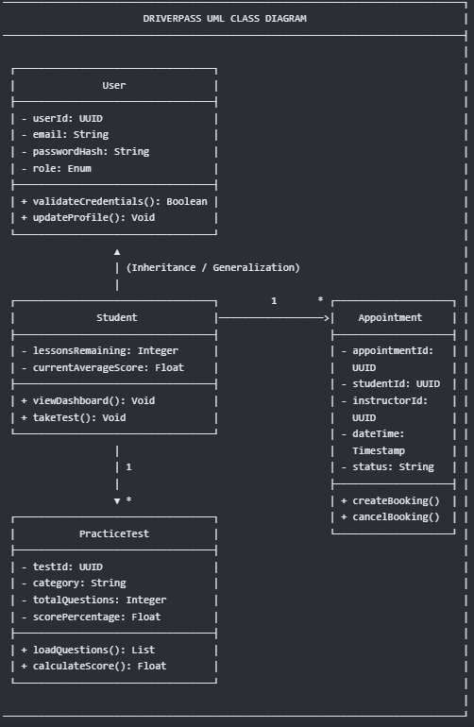]

Technical Requirements
[

Hardware Infrastructure Requirements

- Cloud Hosting Platform: The system infrastructure will be deployed using enterprise cloud computing services (such as AWS EC2 or DigitalOcean) to handle variable user traffic and ensure scaling flexibility.
- Server Specifications: Production application servers will utilize multi-core virtual CPUs (vCPUs) with a minimum of 8GB of RAM to process high-volume user activity and ensure core pages load within 2 seconds.
- Storage Systems: The database cluster will deploy SSD-backed block storage systems to guarantee fast read/write actions, low-latency search indices, and immediate automated backups.

Software Requirements

- Host Operating System: Production and staging environments will run on Linux Ubuntu Server instances to maximize underlying system stability, command-line performance, and server-level access security.
- Database Management System: The platform will use a PostgreSQL relational database management system (RDBMS) to handle relational structures for user records, appointment logs, and quiz percentages.
- Application Runtime Environment: The backend services will run on the Node.js runtime engine to manage asynchronous input/output routing and maintain responsive system states.

Development Tools & Frameworks

- Backend Application Framework: The server architecture will deploy the Express.js framework to create lightweight, modular backend REST APIs and securely communicate database records to the client dashboard.
- System Containerization: The complete application environment will be packaged into isolated Docker containers to decouple the code from underlying server updates and streamline cross-platform staging tasks.
- Diagram Architecture Suite: Lucidchart software is utilized as the primary systems engineering visualization engine to construct, evaluate, and export all core object-oriented structures and system flows.

Network & Security Infrastructure

- Transport Layer Security: All public-facing network pathways will utilize TLS 1.3 cryptographic validation methods via Let's Encrypt certificates to enforce global HTTPS encryption for data in transit.
- API Transaction Management: Secure external webhooks and RESTful network layers will be built to securely communicate payment payloads with third-party verification gateways.
- Edge Proxy Routing: An Nginx reverse-proxy setup will act as an edge load balancer to filter request spikes, manage network firewalls, and route incoming browser requests directly to downstream runtime components.

